**Azure portal/ Search > App Registration**

1: In the Search Box type: App Registration

2: Click Add

3: Add the URI as seen below (pingpong is just a name, has no presence in code base)

4: Tick Implicit Grant Flow: “ID Token”

**(Example: SingleSignOn using OAuth/Microsoft A/C) as Azure AD –**

**Single Tenant**

With Hotmail/live account only

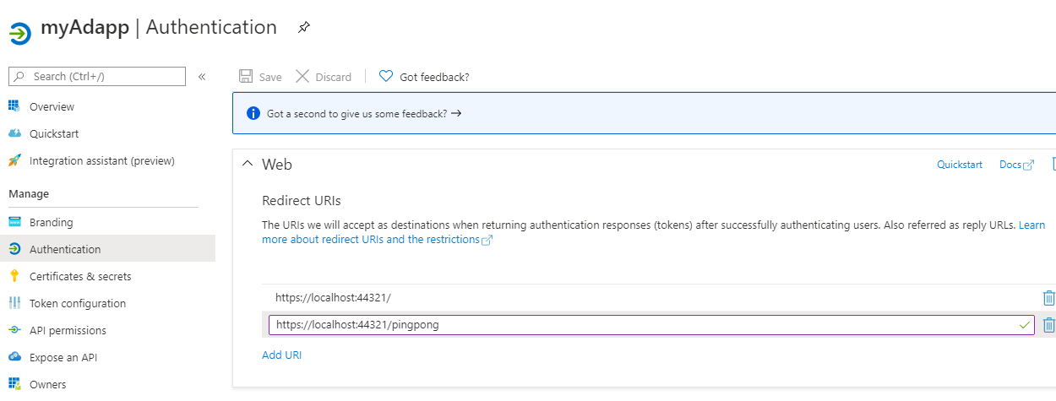

**[Look @ /pingpong]**

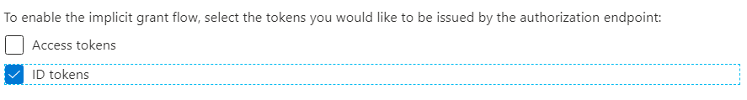

**It has no practical page, however have to be same as in** CallbackPath **below:**

**appsettings.json**

{

"AzureAd": {

"Instance": "https://login.microsoftonline.com/",

"Domain": "[Enter the domain of your tenant, e.g. contoso.onmicrosoft.com]",

"TenantId": "XXX-d636-XXX-9d5f-XXX",

"ClientId": "XXX-XXX-4361-8854-XXX",

"CallbackPath": "/**pingpong**",

"SignedOutCallbackPath ": "/signout-callback-oidc"

},

"Logging": {

"LogLevel": {

"Default": "Information",

"Microsoft": "Warning",

"Microsoft.Hosting.Lifetime": "Information"

}

},

"AllowedHosts": "*"

}

**launchSettings.json**

{

"iisSettings": {

"windowsAuthentication": false,

"anonymousAuthentication": true,

"iisExpress": {

"applicationUrl": "https://localhost:44321",

"sslPort": 44321

}

},

"profiles": {

"WebApp_OpenIDConnect_DotNet": {

"commandName": "Project",

"launchBrowser": true,

"applicationUrl": "https://localhost:44321;http://localhost:3110",

"environmentVariables": {

"ASPNETCORE_ENVIRONMENT": "Development"

}

}

}

}

**Get The Access Token:**

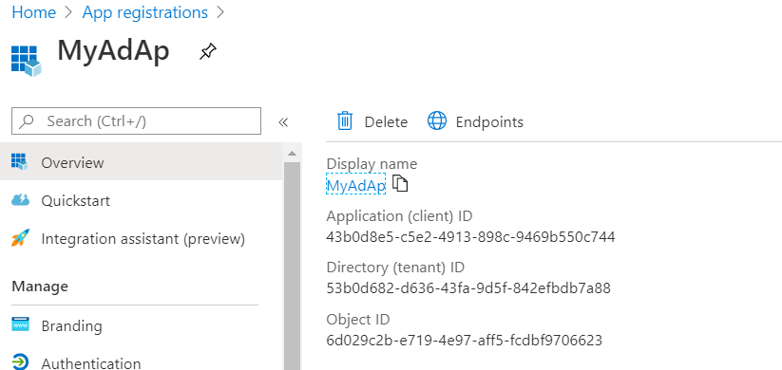

Use it in \appsettings.json file above



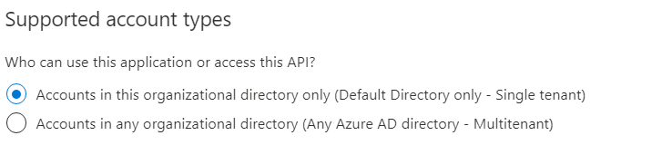

Note:

This works only with Single Tenant (Hotmail/Live Account only) – It does not work with Company Active Directory